Ezra Bakatubia
Andrew Kuruvilla
Marques Roberson
Ruben Valenzuela
Professor Sitaram Ayyagari
ITAI-3377
27 April, 2026

Autonomous Predictive Maintenance Agent for Smart IIoT Systems Using Generative AI
1. Introduction / Project Proposal
The rapid evolution of Industry 4.0 has led to the widespread adoption of Industrial Internet of Things (IIoT) systems, where machines, sensors, and edge devices continuously generate large volumes of real-time data. One of the most critical challenges in such environments is unexpected equipment failure, which can result in costly downtime, safety risks, and operational inefficiencies.
This project proposes a conceptual design of an AI-driven autonomous predictive maintenance agent that leverages Generative AI and edge computing to monitor industrial equipment, predict potential failures, and take autonomous actions in real time. The system is designed to operate at the edge, minimizing latency and enabling faster decision-making compared to traditional cloud-based approaches.
The primary objectives of this system include:
- Reducing equipment downtime through early failure detection
- Improving operational efficiency and productivity
- Enhancing worker safety by preventing hazardous situations
- Lowering maintenance costs through predictive strategies
By integrating generative AI models with autonomous decision-making mechanisms, this system represents a scalable and intelligent solution for modern smart factories.

2. System Architecture (Conceptual)
The proposed system follows a multi-layer architecture that integrates IIoT sensors, edge computing devices, AI models, and an autonomous agent.
Data Flow Overview
- Sensors Layer
Industrial machines are equipped with sensors that monitor parameters such as temperature, vibration, pressure, and operational cycles.
- Edge Layer
Sensor data is transmitted to edge devices using lightweight communication protocols such as MQTT (Message Queuing Telemetry Transport). Edge devices preprocess and filter the data to reduce noise and bandwidth usage.
- AI Processing Layer
Preprocessed data is fed into a generative AI model deployed at the edge. This model analyzes patterns, detects anomalies, and generates predictive insights.
- Autonomous Agent Layer
An intelligent agent evaluates AI outputs and makes decisions using predefined rules and adaptive learning strategies.
- Action Layer
Based on the decision, the system can:
- Trigger alerts to maintenance teams
- Adjust machine operation parameters
- Schedule maintenance automatically
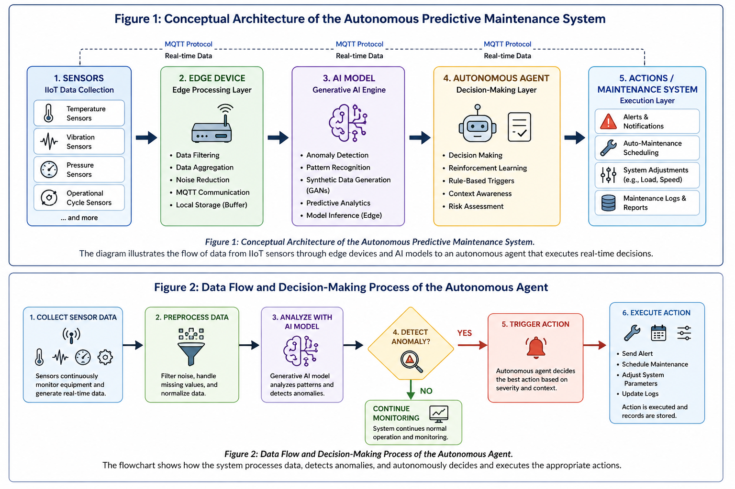

Communication and Protocols
- MQTT for real-time, low-latency communication
- HTTP/REST APIs for system integration
- TLS encryption for secure data transmission
This architecture ensures real-time responsiveness, scalability, and reliability, which are essential for IIoT environments.

3. AI Model Design (Generative AI Approach)
The system incorporates Generative AI techniques to enhance predictive capabilities and improve model robustness.
Synthetic Data Generation
Generative models, such as Generative Adversarial Networks (GANs), are used to create synthetic datasets that simulate rare failure scenarios. This helps overcome the limitation of insufficient real-world failure data.
LLM-Assisted Decision Support
Large Language Models (LLMs) can be conceptually integrated to interpret system outputs and provide contextual explanations for maintenance decisions, improving transparency and usability.
Autonomous Decision-Making
The system combines:
- Reinforcement Learning (RL): to optimize decision-making over time
- Rule-based triggers: for immediate responses to critical conditions
For example:
- If vibration exceeds a threshold → trigger alert
- If anomaly persists → schedule maintenance automatically
Tools (Conceptual)
If implemented, tools such as:
- TensorFlow Lite
- Edge Impulse
- PyTorch Mobile
would be used for deploying lightweight models on edge devices.

4. Security & Ethical Considerations
Security Measures
Given the sensitivity of industrial systems, strong security mechanisms are essential:
- Encryption: All data transmissions are secured using TLS/SSL protocols
- Authentication: Devices and users are authenticated using secure credentials
- Access Control: Role-based access ensures only authorized personnel can interact with the system
Privacy Protection
Although IIoT systems primarily handle machine data, any associated user or operational data must be protected to prevent unauthorized access or misuse.
Ethical Considerations
- Bias in AI Models: Synthetic data generation must avoid introducing biased patterns
- Transparency: Decisions made by autonomous agents should be explainable
- Accountability: Human oversight must remain in place for critical decisions
These considerations ensure that the system operates responsibly and aligns with ethical AI principles.

5. Implementation & Testing Plan (Conceptual)
Although this project is conceptual, a theoretical implementation strategy is outlined.
Deployment Plan
- Deploy edge devices close to industrial equipment
- Install AI models locally for real-time inference
- Integrate system dashboards for monitoring and control
Testing Scenarios
- Performance Testing
- Measure latency and response time
- Evaluate system scalability under high data loads
- Failure Simulation
- Simulate abnormal sensor readings
- Verify accuracy of failure predictions
- Security Testing
- Simulate cyberattacks (e.g., unauthorized access attempts)
- Test encryption and authentication mechanisms
- Stress Testing
- Evaluate system stability under continuous operation
Performance Metrics
- Prediction accuracy
- False positive/negative rates
- System response time
- Resource utilization
This testing plan ensures that the system is reliable, secure, and efficient before real-world deployment.

6. Challenges & Future Improvements
Challenges
- Limited availability of real-world failure data
- Computational constraints at the edge
- Integration with legacy industrial systems
- Ensuring cybersecurity in distributed environments
Future Improvements
- Integration with cloud systems for hybrid processing
- Advanced anomaly detection using deep learning
- Improved explainability using AI visualization tools
- Expansion to other industries such as healthcare and energy

Real-World Impact and Team Contribution
In a real smart factory, this autonomous predictive maintenance agent could significantly improve daily operations by reducing unplanned downtime and helping maintenance teams make faster decisions. Instead of waiting for a machine to fail, the system would continuously monitor equipment behavior and identify early warning signs before they become serious problems. This would allow companies to save money, protect workers, and extend the useful life of expensive industrial machines.
This project also demonstrates how different technical areas work together in an Industry 4.0 environment. IIoT sensors provide the raw data, edge devices process information close to the machines, generative AI improves prediction by creating synthetic failure examples, and the autonomous agent makes decisions based on risk and system conditions. As a group, our team focused on designing a solution that is realistic, secure, and scalable. The main lesson from this planning process is that successful AI systems are not only about advanced models, but also about architecture, cybersecurity, ethics, and reliable testing.

7. Conclusion
This project presents a conceptual design of an AI-driven autonomous predictive maintenance system for IIoT environments. By combining Generative AI, edge computing, and autonomous agents, the system enables real-time monitoring, intelligent decision-making, and proactive maintenance strategies.
The proposed solution addresses key challenges in modern industrial systems by improving efficiency, reducing costs, and enhancing safety. While the project remains conceptual, it provides a comprehensive blueprint for implementing intelligent, scalable, and secure AI systems in Industry 4.0 environments.

